Wednesday 12 December 2018, 4.20pm – 6.30pm
Lecture Theatre 12, Wilberforce Building

US-Israel Relationships 1947-2001

Professor Raphael Cohen-Almagor
Chair in Politics
University of Hull, UK

Abstract

The aim of this lecture is to explain the development of US-Israel relationships from the 1947 UN partition plan until the end of the Clinton presidency in 2001. The presentation analyses the interests of the relevant American administrations (no. 33-42), from Harry S. Truman to William J. Clinton, and how they manifested themselves vis-a-vis Israel. The lecture explains the slow buildup of relationships, the ups and downs, the key factors that played a part in shaping the American perspective, and the reasons for the close alliance between the two countries, as is clearly evident today.

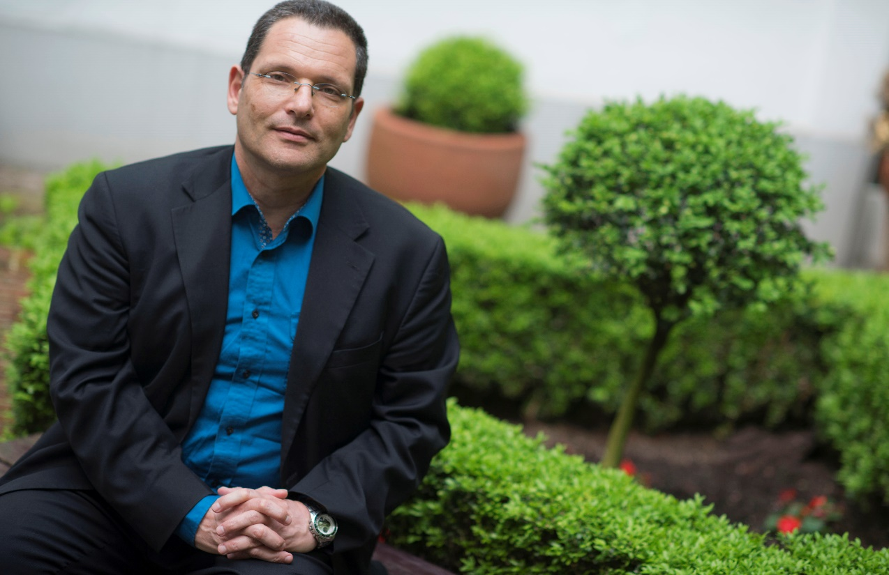

Biography

Raphael Cohen-Almagor, DPhil Oxford, is Chair in Politics, and Founding Director of The Middle East Study Group, University of Hull. He has founded several other organizations, including "The Second Generation to Holocaust and Heroism Remembrance" Organization (1982-1987); The Van Leer Medical Ethics Think-tank (1995-1998), and The Center for Democratic Studies, University of Haifa (2003-2007). Raphael was Fulbright-Yitzhak Rabin Visiting Professor at UCLA School of Law (1999-2000), Visiting Professor at Johns Hopkins University (2003-2004), and Fellow at the Woodrow Wilson International Center for Scholars (2007-2008). To date he has published seventeen books and more than 200 articles in the fields of political science, philosophy, law and ethics, including The Boundaries of Liberty and Tolerance (1994), The Right to Die with Dignity (2001), Speech, Media and Ethics (2001, 2005), The Scope of Tolerance (2006, 2007), and Confronting the Internet's Dark Side (2015). Presently he is writing two books: one on the Israeli-Palestinian peace process and another on multiculturalism. He is also completing his third book of poems.

Date: Wednesday 12 December 2018, 4.20pm – 6.30pm
Venue: Lecture Theatre 12, Wilberforce Building

All are welcome to attend.

